**TRIPHUB:** **CONNECTING TRAVELERS WITH TRAVEL AGENCIES SYSTEM**

**SITI AINA NAZURAH BINTI ZAKARIA**

**FACULTY OF INFORMATICS AND COMPUTING**

**UNIVERSITI SULTAN ZAINAL ABIDIN**

**2024**



**TRIPHUB: CONNECTING TRAVELERS WITH TRAVEL AGENCIES**

SITI AINA NAZURAH BINTI ZAKARIA

THIS THESIS IS SUBMITTED IN PARTIAL FULFILLMENT

OF THE REQUIREMENT FOR THE DEGREE OF

BACHELOR COMPUTER SCIENCE

(SOFTWARE DEVELOPMENT)

FACULTY OF INFORMATICS AND COMPUTING

UNIVERSITI SULTAN ZAINAL ABIDIN

2024

DECLARATION

I hereby declare that the TripHub: Connecting Travelers with Travel Agencies System

is based on my original work except for quotations and citations, which have been duly acknowledged. I also declare that it has not been previously or concurrently submitted for any other degree at University Sultan Zainal Abidin or other institutions.

Aina

_______________________________

Name: Siti Aina Nazurah binti Zakaria

Date: //2025

ACKNOWLEDGEMENT

**“In the name of Allah, Most Gracious, Most Merciful”**

This Final Year Project report could not have been conducted without the support, encouragement, and cooperation of many people. First of all, thanks to Allah Almighty for giving me strength and provided me with good health throughout this project. Secondly, I have to thank my parents for their love and support throughout my life. Thank you both for giving me strength to reach for the stars and chase my dreams. Then, I would like to sincerely thank my supervisor, Madam Fauziah Ab Wahab, for her guidance and support throughout this study and specially for her confidence in me. I would like to thank her for giving the opportunity to learn and work under her guidance. Also thank to all my lecturers, which has been teaching me which guide me to make this project possible. In addition, to all my friends, thank you for your understanding and encouragement in many moments of crisis. Their engorgement, criticism and support help me a lot. Your friendship makes my life a wonderful experience. I cannot list all the names here, but you are always on my mind. Thank you.

TABLE OF CONTENTS

**PAGE**

DECLARATION i

ACKNOWLEDGEMENT ii

TABLE OF CONTENTS iii

LIST OF ABBREVIATIONS v

LIST OF TABLE vi

LIST OF FIGURE vii

ABSTRACT viii

ABSTRAK ix

CHAPTER 1 INTRODUCTION

1.1 Introduction 1

1.2 Project Background 2

1.3 Problem Statement 3

1.4 Objectives 4

1.5 Scope 4

1.6 Limitation of Work 6

1.7 Expected Result 6

1.8 Activities, Milestones (Gantt Chart) 7

1.9 Summary of the chapter 7

CHAPTER 2 LITERATURE REVIEW 8

2.1 Introduction 8

2.2 Theory and Technique 8

2.2.1 Monte Carlo simulation 8

2.2.2 Critical Path Method (CPM) 9

2.2.3 Program Evaluation and Review Technique (PERT) 10

2.3 Existing System 11

2.3.1 AgriWebb 12

2.3.2 Granular 14

2.3.3 FarmLogic 16

2.4 Summary of Technique 15

2.5 E-Ladang FBIM Management System App Implementation with

Critical Path Method 19

2.5.1 Critical Path Method Formula 17

2.6 Summary of the chapter 21

CHAPTER 3 METHODOLOGY 25

3.1 Introduction 25

3.2 Iterative Model 26

3.3 Development Phase 27

3.3.1 Phase 1: Planning and Requirement 27

3.3.2 Phase 2: Analysis and Design 27

3.3.3 Phase 3: Implementation 28

3.3.4 Phase 4: Testing 28

3.3.5 Phase 5: Evaluation 29

3.4 System Requirement 29

3.4.1 Software Requirement 30

3.4.2 Hardware Requirement 30

3.5 Framework Design 31

3.6 System Design and Modelling 32

3.6.1 Context diagram 33

3.6.2 Data Flow Diagram (DFD) Level 0 34

3.7 Data Flow Diagram (DFD) Level 1 37

3.7.1 Manage User 37

3.7.2 Manage Project 38

3.7.3 Manage Task 39

3.7.4 Manage Category 39

3.7.5 Manage Progress 40

3.7.6 Manage borrow garden tools 41

3.7.7 Manage Report 42

3.8 Data Modelling 43

3.8.1 Entity Relationship Diagram (ERD) 43

3.8.2 Data Dictionary 44

3.8.2.1 Table Supervisor 44

3.8.2.2 Table Workers 45

3.8.2.3 Table Project 46

3.8.2.4 Table Task 46

3.8.2.5 Table Category 47

3.8.2.6 Table Gardening Tools 47

3.8.2.7 Table Progress 48

3.9 Summary of the chapter 48

REFERENCES 49

LIST OF ABBREVIATIONS

|  |  |
| --- | --- |
| SPSS | Statistical Package for the Social Sciences |
| UniSZA | University Sultan Zainal Abidin |
| LISREL | Linear Structural Relations |
| WOM | Word-of-mouth |
| SEM | Structural Equation Modeling |
| PLS-SEM | Partial Least Squares Structural Equation Modeling |
| AMOS | Analysis of Moment Structures |
| STA | Smart Travel Agency |
| DOI | Diffusion of Innovations |
| TOE | Technology-Organization-Environment |
| ES | Latest Start |
| SDLC | Software Development Lifecycle |
| CD | Context Diagram |
| DFD | Data Flow Diagram |
| ERD | Entity Relationship Diagram |

LIST OF TABLES

|  |  |  |
| --- | --- | --- |
| Table No. | Title | Page |

Table 2.1: AgriWebb 12

Table 2.2: Granular 14

Table 2.2: Farmlogic 16

Table 2.4: Related Research Techniques 18

Table 2.5: Example demonstrating how the Critical Path Method 24

Table 3.1: List of Software Requirements 30

Table 3.2: List of Hardware Requirement 27

Table 3.3: Table Supervisor 44

Table 3.4: Table Workers 45

Table 3.5: Table Project 45

Table 3.6: Table Task 46

Table 3.7: Table Category 47

Table 3.8: Table Gardening Tools 47

Table 3.9: Table Progress 48

LIST OF FIGURE

|  |  |  |
| --- | --- | --- |
| Figure No. | Title | Page |

Figure 1.1: Gantt Chart 9

Figure 2.1: Research AgriWebb 13

Figure 2.2: Research Granular  15

Figure 2.3: Research FarmLogic  17

Figure 2.4: Critical Path Method Formula 20

Figure 2.5: Forward Pass Formula 21

Figure 2.6: Backward Pass Formula  22

Figure 2.7: Total Float (Slack) Formula  20

Figure 3.1: Iterative Model 26

Figure 3.2: Framework Design 32

Figure 3.3: Context Diagram  33

Figure 3.4: Data Flow Diagram Level 0  36

Figure 3.5: Data Flow Diagram Level 1 (Manage User) 37

Figure 3.6: Data Flow Diagram Level 1 (Manage Project) 38

Figure 3.7: Data Flow Diagram Level 1 (Manage Task)  39

Figure 3.8: Data Flow Diagram Level 1 (Manage Category)  40

Figure 3.9: Data Flow Diagram Level 1 (Manage Progress) 40

Figure 3.10: Data Flow Diagram Level 1 (Manage borrow garden tools)  41

Figure 3.11: Data Flow Diagram Level 1 (Report) 42

Figure 3.12: Entity Relationship Diagram (ERD)  43

ABSTRACT

The TripHub: Connecting Travellers with Travel Agencies System serves as an innovative solution for efficient farm management, leveraging mobile technology to streamline agricultural processes. aims to revolutionize agricultural practices by addressing several key challenges faced by farmers. Firstly, the existing system lacks proper documentation and file management for efficient data entry. Additionally, the reliance on traditional methods for borrowing gardening tools poses logistical issues and delays in agricultural processes. The manual planning of tasks and crops further compounds the inefficiencies in farm management. The primary goal of this project is to streamline and modernize these processes through a user-friendly mobile application. By implementing this solution, farmers will benefit from a centralized platform that facilitates seamless data entry, eliminates the need for physical file storage, and enhances the overall planning and management of tasks and crops. The development methodology use in this project is Iterative model. This app is developed using Critical Path Method (CPM) algorithms. The employ tools such as android studio for coding and firebase for database management. The expected results include improved productivity, resource optimization, and a more sustainable and organized approach to agriculture. In conclusion, the Mobile Apps E-Ladang FBIM Management System stands as a pivotal advancement in agricultural technology, this application also promises user convenience and satisfaction, finally becoming a useful resource in the field of agriculture especially for FBIM UniSZA farm management. aiming to empower workers with efficient tools to enhance productivity and ensure sustainable farming practices.

ABSTRAK

*Sistem Pengurusan FBIM E-Ladang Mudah Alih berfungsi sebagai penyelesaian inovatif untuk pengurusan ladang yang cekap, memanfaatkan teknologi mudah alih untuk menyelaraskan proses pertanian. bertujuan untuk merevolusikan amalan pertanian dengan menangani beberapa cabaran utama yang dihadapi oleh petani. Pertama, sistem sedia ada tidak mempunyai dokumentasi yang betul dan pengurusan fail untuk kemasukan data yang cekap. Selain itu, pergantungan pada kaedah tradisional untuk meminjam alat berkebun menimbulkan isu logistik dan kelewatan dalam proses pertanian. Perancangan tugas manual dan tanaman menambahkan lagi ketidakcekapan dalam pengurusan ladang. Matlamat utama projek ini adalah untuk memperkemas dan memodenkan proses ini melalui aplikasi mudah alih yang mesra pengguna. Dengan melaksanakan penyelesaian ini, petani akan mendapat manfaat daripada platform terpusat yang memudahkan kemasukan data yang lancar, menghapuskan keperluan untuk penyimpanan fail fizikal, dan meningkatkan perancangan dan pengurusan keseluruhan tugas dan tanaman. Metodologi pembangunan yang digunakan dalam projek ini ialah model Iteratif. Aplikasi ini dibangunkan menggunakan algoritma Kaedah Laluan Kritikal (CPM). Menggunakan alatan seperti studio android untuk pengekodan dan firebase untuk pengurusan pangkalan data. Hasil yang dijangkakan termasuk produktiviti yang lebih baik, pengoptimuman sumber, dan pendekatan pertanian yang lebih mampan dan teratur. Kesimpulannya, Sistem Pengurusan FBIM Mobile Apps E-Ladang berdiri sebagai kemajuan penting dalam teknologi pertanian, aplikasi ini juga menjanjikan kemudahan dan kepuasan pengguna, akhirnya menjadi sumber yang berguna dalam bidang pertanian khususnya untuk pengurusan ladang FBIM UniSZA. bertujuan untuk memperkasakan pekerja dengan alat yang cekap untuk meningkatkan produktiviti dan memastikan amalan perladangan yang mampan.*

# CHAPTER 1

## Introduction

In recent years, the travel industry’s digital transformation has changed how travelers organize and reserve trips, creating a fiercely competitive environment where user experience and convenience are key. Studies show that contemporary travelers appreciate efficient platforms enabling them to reserve flights, lodging, and activities through one interface, minimizing the time and effort needed for trip planning (Parolin & Boeing, 2019). Nonetheless, the majority of current platforms are still disjointed, necessitating that users alternate among different sites to finalize their travel plans, potentially resulting in lost chances for personalization and seamless integration throughout booking procedures (Pinto & Castro, 2019). With an increasing number of travelers looking for tailored and effective booking options, the necessity for a unified, easy-to-use travel booking platform is becoming clear (Sharma & Sharma, 2023). The pursuit of customized travel experiences is further fueled by improvements in recommender systems and data analytics, allowing platforms to generate recommendations according to user preferences and actions. Research on multi-criteria collaborative filtering within travel platforms indicates that recommendation systems can greatly enhance user satisfaction by matching choices to personal interests, boosting engagement, and fostering customer loyalty (Nilashi et al., 2015). Although these technological advancements exist, numerous existing travel platforms fail to fully utilize user data to create a smooth, personalized experience, frequently leading to broad recommendations that do not address individual preferences (Gholipour Soleimani & Einolahzadeh, 2018). To bridge this gap, a unified travel platform featuring sophisticated preference matching could transform the way users engage with travel booking services (Nurbadi et al., 2019). Additionally, small and medium-sized travel agencies encounter considerable difficulties in connecting with potential clients online, as major travel companies lead in digital marketing and exposure. The use of digital marketing and web platforms by small agencies is still restricted, primarily because of technological and resource limitations, affecting their capacity to engage a wider audience (Singh & Ranjan, 2019). Studies show that centralized platforms providing smaller agencies with an accessible marketplace can enhance their visibility and competitiveness in the digital landscape (Dalilah et al., 2020). The TripHub platform seeks to simplify booking processes, improve user satisfaction via personalization, and assist smaller agencies in broadening their market reach by creating a centralized platform that links agencies with travelers.

## Project background

The travel sector has experienced major digital changes, transforming the way individuals organize and reserve their vacations. Despite these progressions, smaller travel agencies are finding it hard to compete with already reputable platforms. Most of the smaller agencies do not have the necessary digital tools, marketing reach and technological skills to compete for new customers and retain those already existing. This hinders their capacity to promote distinct travel offerings, leading to lower exposure and market competitiveness.

TripHub's goal is to support small and medium-sized travel agencies by offering a centralized digital platform tailored to their specific needs. The system helps agencies easily create, handle, and advertise their travel packages, enabling them to expand their reach without requiring advanced technical skills or expensive marketing strategies. TripHub improves the agency's personalized services and customer relationships by incorporating customizable trip listings, real-time booking updates, and direct traveler interaction.

## Problem Statement

There are several problems that can be observed through current travel planning and booking landscape. The first problem statement is restricted online presence for small and medium-sized travel agencies. Small and medium-scale travel agencies are often challenged to appear and compete on the web against larger, established platforms. They cannot afford sophisticated digital marketing methodologies or robust online infrastructures, hence failing to appeal to a wider customer base.

Another significant difficulty faced by travel agency without a proper landscape of system is booking processes are split up on various platforms. Travelers often find themselves inconvenienced by booking flights, accommodations, and activities on different platforms. This fragmented process leads to a lot of inefficiencies and time consumption, with a lack of cohesive trip planning.

Furthermore, travel agency often relying on external platforms for marketing and sales. Small travel agencies often have to depend on third-party marketing and selling platforms. Although these platforms offer visibility, they charge very high commission fees and limit the agencies' control over branding and customer interaction. This dependence results in reduced profitability and a lack of innovation.

## Objectives

The objective of this project is to reduce challenges and make the TripHub system more reliable, thereby increasing user efficiency. To ensure the system provides an efficient and flexible platform for all users administrators, travel agencies, and travelers with a user-friendly interface, the objectives are as follows:

1. To analyse the difficulties small and medium-sized travel agency to compete with bigger platforms.
2. To develop a centralized platform that enables small and medium-sized travel agencies to display trips, handle reservations, and interact with customers.
3. To test the effectiveness of a specialized platform empowers travel agencies to decrease dependence on third-party platforms without sacrificing profits.

## Scope

There are three users who use this TripHub system namely admin, travel agency and travellers. Every user category is assigned particular rights and restrictions within the platform, as detailed underneath:

1. **Admin**

* Log in
* Manage user accounts
* View and approve trip packages submitted by travel agencies
* Monitor bookings, payments, and refund processes
* Provide data analytics and reports
* Handle disputes and complaints

1. **Travel agencies**

* Register
* Login
* Update agency profile
* Create and manage trip listings. (Input and update trip details, including destination, duration, itinerary, and price for each package)
* View and manage bookings
* Update booking status
* Can interact with travellers

1. **Travelers**

* Register
* Log in
* Update profile
* View profile
* Can browse and filter trips by searching for options based on destination, duration, and price preferences.
* View detailed trip information
* Make booking and payments
* Can review and rate trips
* Can request customizations

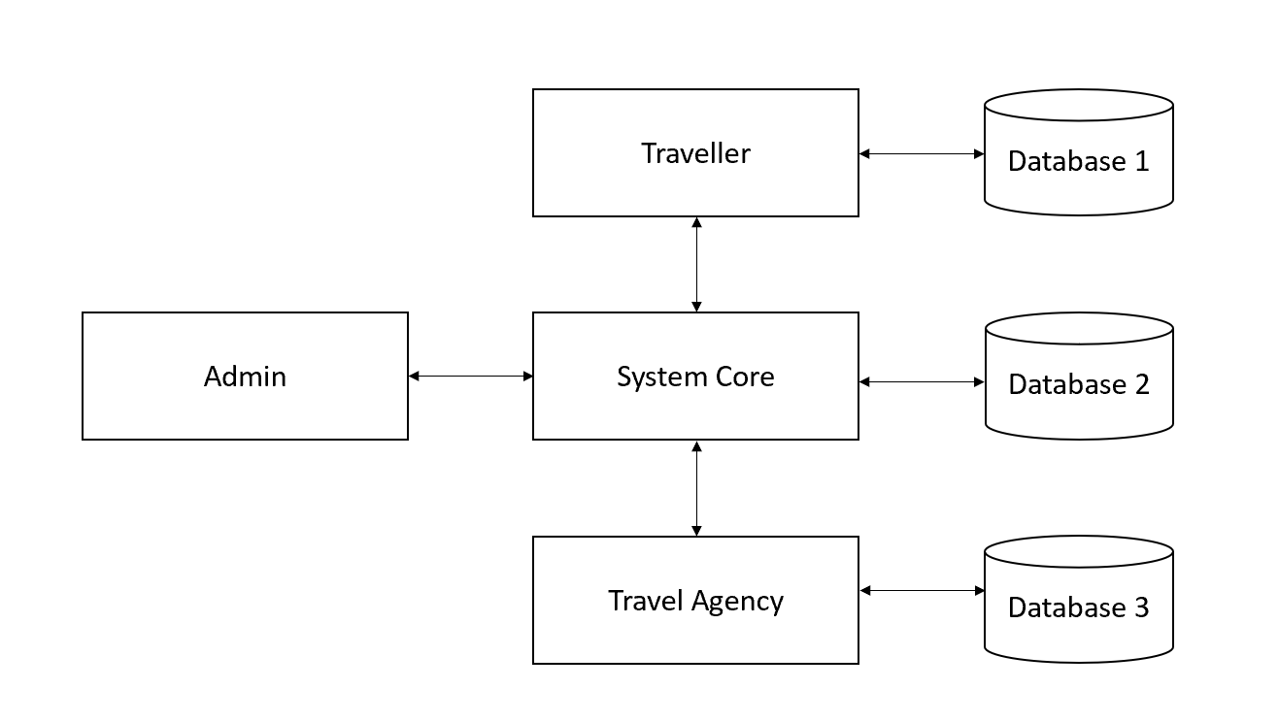

**Figure 1.1: Framework Diagram**

1. How the system works:
   1. **User Authentication:**

* Both travelers and travel agencies will log into TripHub using unique credentials. This will ensure secure access and personalized experiences based on user roles.
  1. **Travel Agency Actions:**
* Input Trip Details: Agencies can create and manage trip packages by inputting relevant details such as destination, duration, number of participants, and itinerary.
* Monitor Bookings: Agencies can view and manage incoming bookings, update trip availability, and communicate with users for custom requests.
* Update Profiles: Agencies have the option to update their profile information, enhancing their branding and trustworthiness on the platform.
  1. **Travelers Action**
* Browse and Filter Trips: Travelers can use advanced search and filter options to find trips matching their preferences.
* View Detailed Trip Information: Each trip package will include comprehensive details to assist travelers in making informed decisions.
* Make Bookings: Users can book their chosen trips through a secure checkout process integrated within the platform.
* Provide Feedback: After completing their trips, travelers can rate and review their experiences, contributing to the platform's credibility and aiding future users.
  1. **Admin Oversight:**
* Review and Approve Listings: The admin will ensure that all trip listings meet platform standards before they go live.
* Monitor Platform Usage: The admin can track user activity, analyze metrics, and generate reports for performance evaluation.
* Manage Users: Admins can oversee user registrations, handle permissions, and provide support as needed.
  1. **Automation and Notifications:**
* Automated Alerts: The system will notify travelers of booking updates and send reminders about upcoming trips.
* Real-Time Updates: Agencies and travelers receive real-time updates on bookings and trip status changes, enhancing communication and responsiveness.

## Limitation of Work

There are some limitations to the use of this TripHub: Connecting Travelers With Travel Agencies. The first one is, market acceptance and user adoption,as persuading people to transition from traditional methods or existing platforms can be difficult, especially in competitive markets. Next, the platform's success is heavily reliant on **active engagement from partnered travel agencies,** as its value depends on the completeness and consistency of their input. Furthermore, the system will initially focus on the Terengganu region, limiting its outreach during the early stages of its launch to ensure a concentrated and effective implementation.

## Expected Outcome

## The expected outcomes for TripHub include several key benefits. First, the platform aims to achieve increased user engagement, as travelers will find it simpler to search, compare, and book travel packages. This can be measured using metrics such as website visits, platform engagement duration, and booking volume. Additionally, enhanced user satisfaction is anticipated through streamlined booking procedures and consistent trip details, which will be evaluated using post-trip feedback, ratings, and reviews from users. Furthermore, the platform will significantly improve agency market visibility by offering small travel agencies a centralized space to efficiently promote their trips, helping them gain better exposure in the competitive travel market.

## Activities, Milestones (Gantt Chart)

The gantt chart show the milestone TripHub: Connecting Travellers and Travel Agencies for each chapter can be followed according to the expected timeline given:

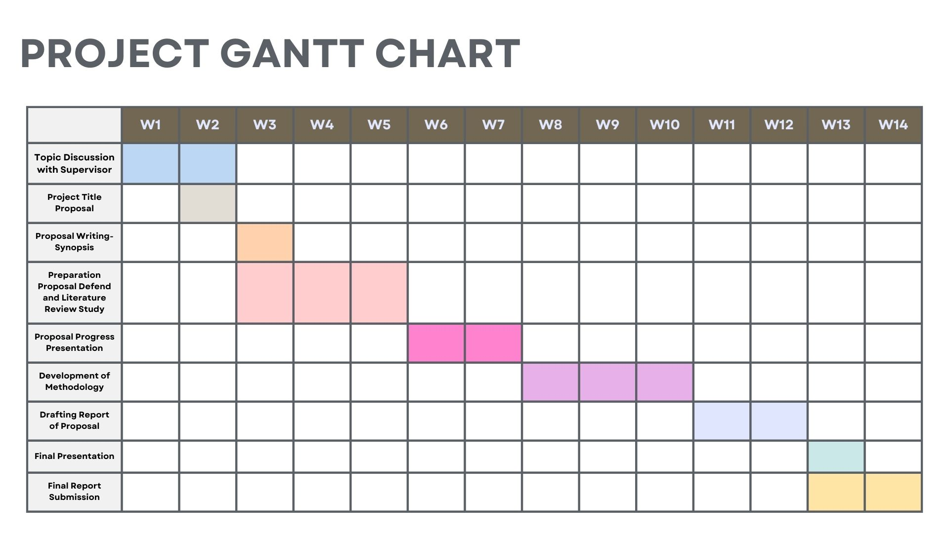

**Figure 1.1: Gantt Chart**

## Summary of the chapter

To make a summary, Chapter 1 which is Introduction gives an overview of the concept of the system that will be developed which is TripHub System. Based on the overview mentioned, the development of this system can provide a positive impact in the travel landscape.

# LITERATURE REVIEW

## Introduction

In this section concentrates on reviewing literature for the TripHub: Connecting Travelers with Travel Agencies system, gathering information on digital travel platforms and user-centered booking systems. This chapter also lays the groundwork for introducing enhanced editions of the system. Performing a literature review is crucial to comprehend the existing scenario and collect pertinent data on comparable platforms. A study has been conducted on current systems to gain a deeper understanding of the obstacles and possibilities for this project. The conversation involves examining existing travel booking websites, strategies to overcome their restrictions, and innovations to improve customer satisfaction. Different journals and articles were examined to find the most effective methods for establishing a personalized travel booking system. The review of literature in this project will investigate and assess methods for incorporating trip personalization, streamlined booking procedures, and individualized user suggestions on the TripHub platform.

## Theory and Technique

### Structural Equation Modelling (SEM)

Structural Equation Modelling (SEM) is study that used a two-step SEM approach to investigate the relationship between service quality, satisfaction, word-of-mouth, and revisit intention among travellers who utilized Guilan travel agencies. The sample size was 500 respondents, who were selected by Convenience Nonprobability Sampling, and SPSS and LISREL software were used for analysis. First, a measurement model was tested using Confirmatory Factor Analysis to validate the relationships between the observed and latent variables. The model consisted of five latent variables, and its goodness-of-fit measures indicated that it was reliable and valid. The second step was to test the structural model, which assessed hypothesized relationships among constructs. Results indicated that service quality has a positive effect on satisfaction and WOM, while satisfaction and WOM have an effect on revisit intention. By using the SEM approach, customer satisfaction and WOM acted as mediators in establishing a strong relationship between service quality and revisit intention. This methodological framework puts in light the usefulness of SEM while investigating complex relationships among constructs, thereby providing strong insights into enhancing service strategies within the travel industry.

### Partial Least Squares Structural Equation Modeling (PLS-SEM)

The Partial Least Squares Structural Equation Modelling (PLS-SEM) is a commonly utilized multivariate statistical method for examining intricate relationships between observed and latent variables, especially in exploratory studies. It emphasizes optimizing the explained variance of dependent variables, making it suitable for models that are inherently predictive. In contrast to covariance-based SEM methods like LISREL or AMOS, PLS-SEM accommodates smaller sample sizes and non-normally distributed data more flexibly. In the research, PLS-SEM was utilized to investigate the elements affecting digital marketing adoption among small travel agencies (STAs) through the combined DOI-TOE framework. This involved evaluating factors like relative benefit, expense, rivalry, and confidence. The validation of the measurement model was conducted through Confirmatory Composite Analysis (CCA), while the structural model was evaluated to foresee digital marketing adoption and its effects on organizational performance. Employing SmartPLS 3 software enabled the research to efficiently examine both reflective and formative constructs. For research initiatives like yours, PLS-SEM is especially beneficial for examining intricate relationships, validating multidimensional constructs, and handling various datasets that do not adhere to stringent statistical criteria.

### Service-oriented architecture (SOA)

Service-Oriented Architecture (SOA) methodologies were utilized in creating the Smart Travel System, concentrating on merging various travel services into a unified platform. The SOAD methodology will be used to analyze and design the system by emphasizing the flexibility and reusability of services. Salient features of the methodology used included service composition, wherein the individual services are combined to provide a smooth workflow; orchestration that oversees the regulation of such services according to changing business needs. It also ensured holistic and flexible implementation through a blend of bottom-up, top-down, and middle-out approaches. The use of SOADL had made cross-platform compatibility and runtime integration of services possible, therefore laying the solid foundation of the system. More important, the study had used a literature-driven approach with a user-focused design. The research identified some issues that are supposed to assure the system meets user demands. Some major issues observed include a lack of integrated service and flexible payment options within agency data and user reviews. The development methodology entailed formulating a Business Model Canvas, which streamlined the business aspects of the system through the development process. This methodological framework, therefore, underlines how SOA is efficient in establishing integrated and user-friendly solutions for the travel industry.

## Existing System

The research on the current and existing systems will be shown in this part. The study was made to give an idea about the system that will be developed, which is the TripHub: Connecting Traveller with Travel Agency system. Among the interesting existing systems are:

#### Viator

The Viator App is a comprehensive platform for reserving tours and activities, available on iOS and Android devices. It offers various features aimed at improving the travel planning process. The application excels in handling curated travel packages, enabling users to effortlessly explore, reserve, and evaluate tours globally. Viator's partnership with Tripadvisor provides access to reliable reviews and suggestions, helping travelers make educated choices. Its intuitive interface allows for smooth searching, comparing, and booking experiences. Viator provides offline access to booking details, allowing travelers to check itineraries and information even without an internet connection. In general, Viator offers travelers a versatile and user-friendly platform to find and reserve distinctive travel experiences, making their trip planning easier.

The research on the existing system Viator is shown in Figure 2.1.

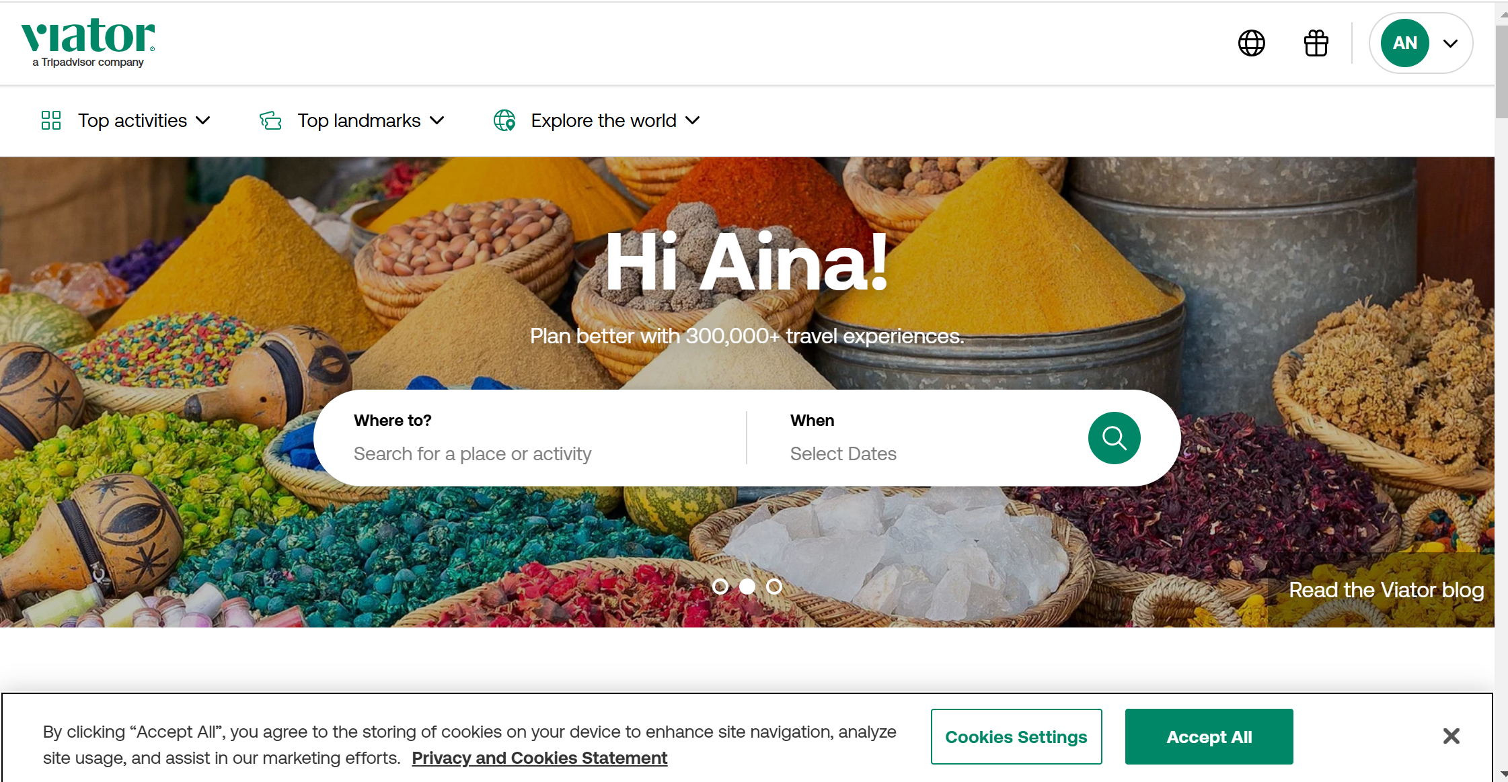

**Figure 2.1: Research Viator**

Table 2.1 shows research about the advantages and disadvantages of finding Viator:

|  |  |  |
| --- | --- | --- |
| **Description** | **Advantage** | **Disadvantage** |
| It specializes in helping travelers discover, book, and manage tours, activities, and attractions worldwide. | * Detailed descriptions, reviews, and photos to aid decision-making. * Secure payment methods and 24/7 customer support. * Multi-language support for a global audience. | * Poor communication between travelers and tour operators * Limited activity options in less popular destinations. * Some activities may have higher pricing than booking directly with providers. |

**Table 2.1: Viator**

### GetYourGuide

The GetYourGuide App is is a travel application and website that focuses on linking travelers with selected tours, activities, and attractions globally. GetYourGuide offering travelers a smooth interface to explore and reserve tours, activities, and entry tickets to attractions globally. The application provides options like skip-the-line passes, guided excursions, mobile tickets, and adaptable cancellation policies, guaranteeing ease and reassurance. Its user-friendly interface enables users to search by location, type, or interest, refine results according to preferences, and view comprehensive descriptions, images, and reviews to help in making informed choices. GetYourGuide streamlines travel planning for memorable adventures through tailored experiences and convenient booking.

The research on the existing system GetYourGuide is shown in Figure 2.2.



**Figure 2.2: Research GetYourGuide**

Table 2.2 shows research about the advantages and disadvantages of finding GetYourGuide.

|  |  |  |
| --- | --- | --- |
| **Description** | **Advantage** | **Disadvantage** |
| It specializes on assisting travelers to find and reserve tailored tours, activities, and entry passes to attractions globally. | * Provides detailed descriptions, photos, and reviews for each activity. * Wide range of activities tailored to various interests. * User-friendly interface with search and filtering options. | * Limited availability for certain destinations or niche activities. * Occasional discrepancies between advertised and actual experiences. * Some activities may have higher pricing than booking directly with providers. |

**Table 2.2: GetYourGuide**

### TourRadar

The TourRadar is an international online platform focused on multi-day tours and travel packages, linking travelers with tour operators and travel agencies. It provides a variety of journeys, such as adventure excursions, cultural experiences, and group travel choices, accommodating different traveler preferences. The platform offers customizable trip options, safe payment methods, user reviews, and easy-to-use search tools, allowing travelers to browse, compare, and book tours effortlessly. TourRadar specializes in managing group travel and adventure excursions, offering organized itineraries and dependable operator collaborations. Its intuitive interface provides seamless navigation for travelers and effective management features for agencies. TourRadar streamlines the travel planning process and improves the overall experience for agencies and travelers by providing marketing visibility and worldwide access for tour operators.

The research on the existing system TourRadar is shown in Figure 2.3.

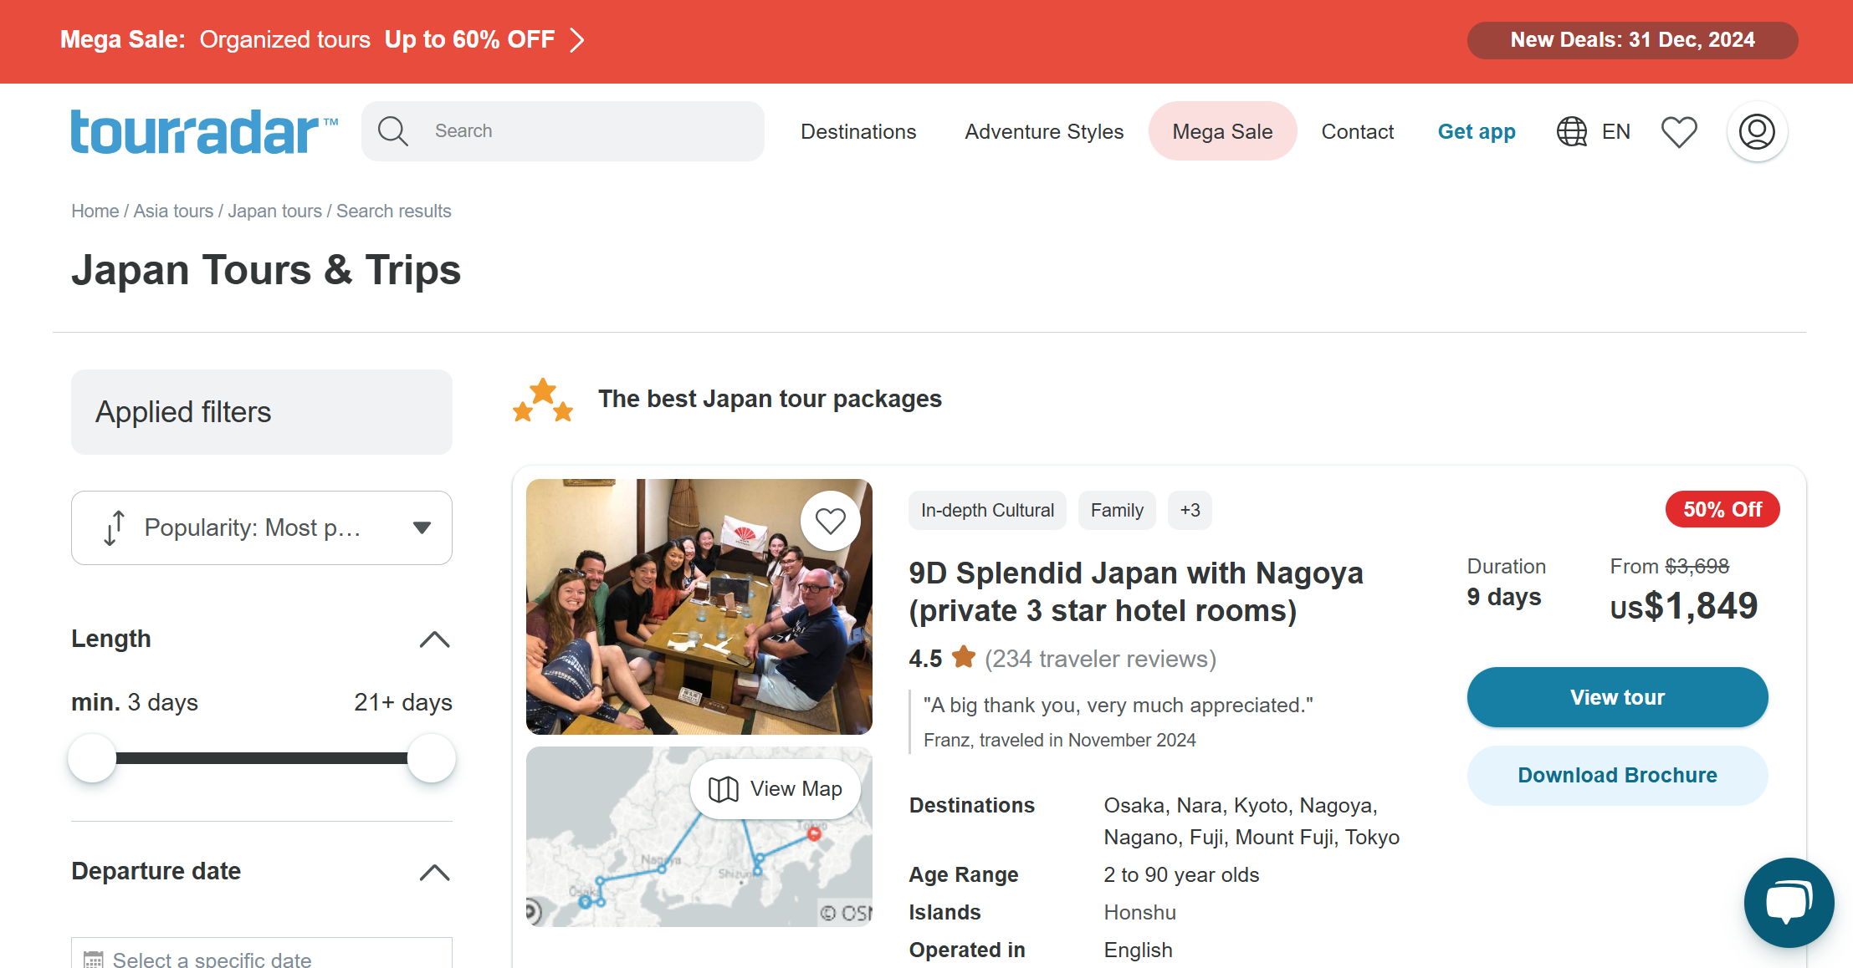

**Figure 2.3: Research TourRadar**

Table 2.3 shows research about the advantages and disadvantages of finding TourRadar.

|  |  |  |
| --- | --- | --- |
| **Description** | **Advantage** | **Disadvantage** |
| It specializes in multi-day tours and travel packages, connecting travelers with tour operators and travel agencies. TourRadar offers a wide range of trips, including adventure tours, cultural experiences, and group travel options. The platform features customizable trip listings, secure payment systems, customer reviews, and intuitive search tools for seamless exploration and booking. | * Provides detailed descriptions, photos, and reviews for each activity. * Wide range of activities tailored to various interests. * User-friendly interface with search and filtering options. | * Limited availability for certain destinations or niche activities. * Occasional discrepancies between advertised and actual experiences. * Some activities may have higher pricing than booking directly with providers. |

**Table 2.2: TourRadar**

## Summary of Technique

Table 2.4 will display research on linked research approaches.

|  |  |  |  |
| --- | --- | --- | --- |
| **Authors** | **Title** | **Method** | **Findings** |
| Gholipour Soleimani & Einolahzadeh (2018) | The influence of service quality on revisit intention: Guilan travel agencies. | Structural Equation Modeling (SEM) |  |
| Sharma & Sharma, 2023 | Digital marketing adoption by small travel agencies | PLS-SEM |  |
| Nurbadi et al., 2019 | Implementation of Smart Travel System | Service oriented architecture (SOA)-based design |  |

REFERENCES

Nurbadi, R., Amyus, A., Pratama, B., Kanz, A. F., Fajar, A. N., & Wang, G. (2019, June). Implementation of Smart Travel System For Support Travel And Accommodation Industry. In *Journal of Physics: Conference Series* (Vol. 1235, No. 1, p. 012029). IOP PublishingI. A., Pratami, D., Yasa, I. P., & Tripiawan, W. (2020). Developing project schedule in telecommunication projects using critical path method (CPM). *International Journal of Integrated Engineering*, *12*(3), 60-67.

Gholipour Soleimani, A., & Einolahzadeh, H. (2018). The influence of service quality on revisit intention: The mediating role of WOM and satisfaction (Case study: Guilan travel agencies). *Cogent Social Sciences*, *4*(1), 1560651.

Sharma, A., & Sharma, S. (2023). Digital marketing adoption by small travel agencies: a comprehensive PLS-SEM model using reflective and higher-order formative constructs. *European Journal of Innovation Management*.

Pinto, I., & Castro, C. (2019). Online travel agencies: Factors influencing tourists’ purchase decisions. Tourism & Management Studies, 15(2), 7-20.

Singh, S. V., & Ranjan, R. (2019). Online travel portal and their effect on travel agency: A study on outbound visitors of Varanasi.

Nilashi, M., bin Ibrahim, O., Ithnin, N., & Sarmin, N. H. (2015). A multi-criteria collaborative filtering recommender system for the tourism domain using Expectation Maximization (EM) and PCA–ANFIS. *Electronic Commerce Research and Applications*, *14*(6), 542-562.

Dalilah, M. S., Albattat, A., Nur Hafify Shazwani, R., Theana, N., & Wan Hamisah, W. H. (2020). The Preferences of Potential Tourists in Utilizing Travel Agencies and Travel Application. *International Journal of Scientific & Technology Research*, *9*(3).